Thy Kingdom Come Basingstoke Ecumenical Novena
TKC Shared Creativity
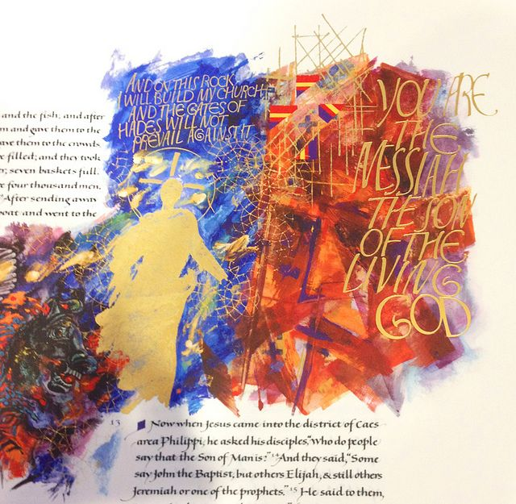
Illuminating the Word
An opportunity to join in taking a book or passage from the bible and engage your parish or community groups in taking a section each to illustrate or transcribe in a way they choose (perhaps with global partners writing in different language too). This could then lead to final compilation of a parish/community hand-crafted edition of the chosen biblical book or passage - binding together creativity from church, school, community, ecumenical, globally-linked groups of the parish.

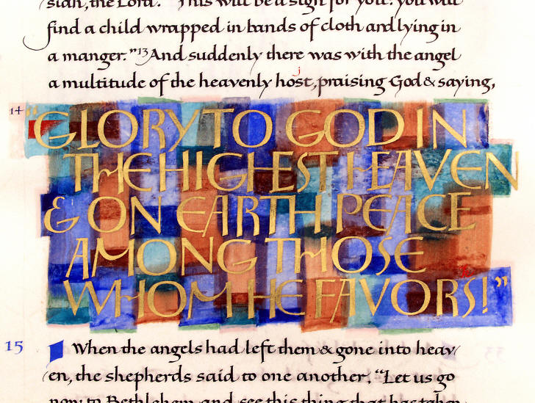
If there are a number of parish or church communities who decide to follow-up this idea, we could gather the final passages or books together to form a shared TKC Basingstoke single volume, to be read from as we worship together on the Eve of Pentecost perhaps.

