More ideas for getting started.
These are only suggestions and if you are going to try a prayer walk, it’s important to do it in a way that feels right for you.
- Start and end together: agree a place and time to meet to start walking and talking to God together.
- Planned route or not? You can decide ahead of time where you’re going to go, or simply wander.
- Try going out in twos: Jesus sent his disciples out in twos. It’s not as intimidating or as conspicuous as a large group can be, and it is safer than going on your own.
- To be seen or not to be seen: you can pray softly or in a volume that doesn’t draw attention. Silence is okay too. It’s not about being seen to be praying, it’s about seeing and praying. Having said that, if you feel confident sometimes the Lord can ask us to pray boldly in public!
- Pray the positive: even in situations that seem ‘desperate’; pray blessings rather than telling God what to do! Focus on God’s plan and purpose for the place and the people that live there. "Your Kingdome come, your will be done..." makes an excellent start.
- Ending well: share what you’ve felt, seen, prayed and heard from God. You might want to keep a record of what you share so you can build on it next time.

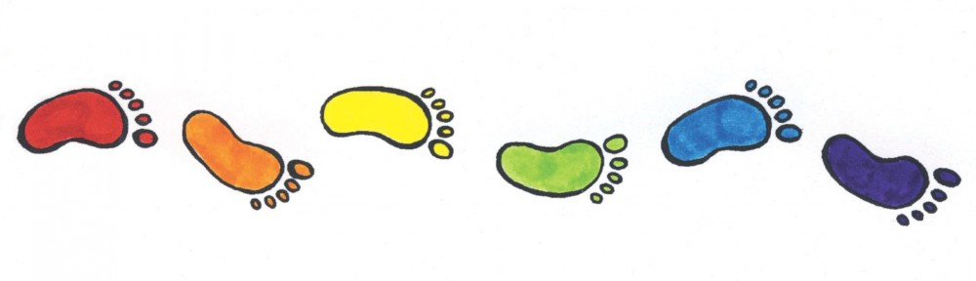

Places where you might want to stop and pray
Probably not all of them on any one prayer walk! Quality rather quantity; pray spontaneously.

Your own home Shop
Your own road Church
Other houses and roads School
Bus shelter Rathbone Pavilion:
Notice Board Youth Club
Telephone box with defibrillator Puddleducks
Pond Playgroup
Fields Parish Council
Playing field Village Trust
Wildlife, nature and pets Village Activities e.g.:
The Sun Art Society
The Fox Yoga
The Wheatsheaf W.I.
Farms Gardening Club
Garden Centre
Bluebells Anywhere else!
Prayer Walking
Pray Walking
Reverently And
Around Listening;
Your Knowingly
Environment Intuitively
Regularly Naming
God

Prayer walking
Enveloping the village in prayer
Prayer walking is a great way to get active in prayer and is as simple as it sounds – you pray as you walk.

What is it?

Walking with a friend or friends, through our own community praying as you go (and it’s good for your health!). Usually it’s being on the scene without making one. It’s a relatively new phenomenon, the origin of which isn’t clear. There’s no biblical model for prayer walking, though since walking was the major mode of transportation in Biblical times, people probably walked and prayed at the same time.
As you walk, pray for the places and people you see around you. You might plan to stop at specific locations, or may just walk and see where you are led – either way, it’s an exciting and engaging way to pray. It is about blessing our community with God’s life, love and power.

Some suggestions to get you started.

Pray with a friend.
- You can prayer walk alone, but many find that prayers are more focused when expressed with a friend.
- Pray out loud if you want, so your partner can join in or say Amen.
- As you finish, discuss – or even write down – what you have prayed for, ready to build on next time.

Pray with Purpose.
- Pray for the needs of people and places that you see.
- Perhaps sketch a map to focus on select streets and homes.
- Explain what you are doing to inquirers: “We’re praying God’s blessing on the village. Are there specific ways we can pray for you or others?”
- Be persistent. Try prayer walking the same areas in a regular way. Prayer-walking uses the sights, sounds, even smells to engage both body and mind in prayer.

